Course #7:
The Great Commission

by Jacob Taube and Aaron Bashore

COURSE DESCRIPTION
A study of the basic principles of The Great Commission. Applications and strategies for implementing the ministry of disciple making and church planting in the culturally diverse settings of today’s world.

Course Structure
Paul explains the mission in a logical way in Romans 10:13-15. He starts with the glorious reality that God is on a mission to save. Then he moves to the logical next step to answer the question, “How does God save?” By preaching. Then he answers a further question, “Who will preach?” Preachers that are sent!

To understand missions we must understand what is our end goal. After understanding what we are supposed to be doing we will have a better idea of how to do it and who to send to accomplish that task.

Section 1: The Mission- What and Why
Lesson 1: God’s Missionary Heart
Lesson 2: What is the mission?
Lesson 3: What is our motivation?
Lesson 4: Where Christ is not named
Section II: The Means- How
Lesson 5: Evangelizing Cities
Lesson 6: Establish Believers
Lesson 7: Exhort to Ministry
Lesson 8: Exercise for Ministry
Lesson 9: Export National Pastors
Lesson 10: Exit Indigenous Churches
Lesson 11: Closed Countries
Lesson 12: Cultural Adaptation and Language Acquisition
Section III: The Missionaries- Who
Lesson 13: The Role of the Local Church
Lesson 14: The Missionary Trainer
Lesson 15: The Missionary Candidate
Lesson 16: The Preparation of the Missionary
Section 1: The Mission

What are we trying to accomplish?

Why are we trying to accomplish it?
Lesson 1 – God’s Missionary Heart

Introduction: Understanding the cosmic significance of missions

- God’s Purposes in Creation (why did God create the world?)

  - The universe as the work of a glorious Triune God (John 17:5, 24, Acts 17:25, Col. 1:16, Rom. 11:36)
B. The paradisiacal condition of the garden (Gen. 1:26-31, 2:7-25)
C. How the Fall affected mankind (Gen. 3:7-24, 4:1-15, Rom. 1:18-25, 5:12, 8:20-22)
D. The great failures of the Antediluvians and at Babel (Gen. 6:3-8, 11:1-9)

II. God’s Selection of a People (why did God choose Israel?)

A. God calls Abraham out of an idolatrous culture (Gen. 12:1-3, Heb. 11:8-10)
B. Promises to Israel unfolded in spite of her repeated failings (Gen. 21:1-3, Ex. 1:7, 33:14, Josh. 21:43-45, Neh. 1)
C. The Mosaic law sets Israel apart as uniquely belonging to God (Lev. 11:44-47, 19:2, 20:7-8)
D. In the tabernacle and temple orders, Israel granted access to the lost presence of God (Ex. 40:34-38, 1 Ki. 8:10-13)
E. As the embryonic people of God, Israel’s history represents the initial phases of God’s work of redemption (Ex. 19:4-6, Rom. 3:1-3)

III. God’s Demonstration of his Greatness (did God care about the world in the OT?)

A. The blessings to Abraham to overflow to the world (Gen. 12:2-3)
B. The manner of God’s works among his people a testimony to his character (Ex. 9:13-16, Josh. 2:10, 1 Sam. 4:8)
C. Instances of Gentiles who receive or respond to a witness in the OT (Jon. 1:2, 3:1-10, 4:10-11)
D. The expectation of God’s eventual worldwide dominion and praise (Ps. 9:11, 18:49, 47:1, Is.49:6, 52:15, 55:5, 56:6-7, 66:18-19)

IV. God’s Fulfillment of his Promises (what changed in the NT era?)

A. Jesus is the ultimate revelation of God’s character and will (Jn. 1:18, 5:19-23, 7:16, 8:19, 12:44-50, 14:8-11, 2 Cor. 4:4, Col. 1:15, Heb. 1:3, 1 Jn. 5:20)
B. Christ’s coming heralds the dawn of God’s glorious kingdom on earth (Mat. 4:17, 8:11, 25:31-34, Lk. 10:9, 16:16, Ac. 7:56, 8:12, Col. 1:12-14, Phil. 2:9-11, Rev. 11:15)
C. His atoning work pays the price for mankind to be restored to God (Rom. 3:21-24, 2 Cor. 5:18-21, Mat. 28:18-20, Jn. 12:20-21, 31-32, Ac. 10:13-15, Rev. 5:9-10)
D. The presence of God is no longer has a geographical hub; the Spirit of God empowers the people of God everywhere (Mat. 28:18-20, Ac. 1:8, 1 Pet. 2:4-10)
E. Worldwide gospel proclamation as the realization of OT hopes (Lk. 24:45-48, Ac. 2:5-8, 13:46-48, 15:13-18, Rom. 15:8-12)

Conclusion: Our moment in redemptive history calls upon us to ‘go and tell’; we must prioritize worldwide disciple-making as the central mission of the church

Lesson 2 – What is the mission?

Introduction. The purpose of this session is to:
1. Feel the individual and the corporate nature of Great Commission as given by Jesus Christ.
2. Understand that missions is not peripheral or optional to local church ministry.
3. Fix our eyes on the accomplishment of the mission: Making disciples of Christ everywhere.

1. The OT foresees a decentralization of God’s plan of salvation for the nations: Sending.

*God sent his Word by the Prophets to Israel (Heb. 1:1). The nations could come to the temple in Jerusalem to learn of God. (1 Ki. 8:41-43, 59-60)

*God promised to send His Word made flesh (Heb. 1:2, John 1:14), the Light of the Nations (Is. 42:6, Luke 2:30-32), the perfect Testator (Is. 53) of the New Covenant (Jer. 31:31-34, Ez. 36:24-32)
What are the details of the New Covenant?
1. God’s Word would be written on our hearts
2. God would be their God and they would be their people
3. An inner knowledge of God
4. Total Forgiveness
5. An indwelling Spirit

*God explains how sending saved Jews will result in recruitment of saved Gentiles for his sending plan (Is. 66:19-21). The period between sending and gathering is where we now live.

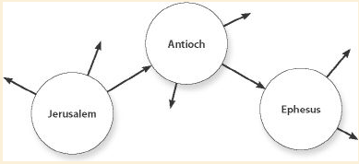
NT Missions: All believers going everywhere telling everyone

2. Jesus Christ inaugurates the mission

*The indwelling of the Spirit and the sending of the witnesses (Acts 1:6-8)

*Jesus: “As the Father has sent me, so send I you” (John 20:21-23)
How?
1. He indwells and empowers them (vs 22) The indwelling Spirit not in the temple but in us (John 4:21-24, Eph. 2:19-22, 1 Pet. 2:5). The temple becomes mobile.
2. Their preaching bring forgiveness of sin (vs. 23) (Rom. 10:13-15)
3. They must now carry their cross (Matt. 10:38, Mark 8:34-35)

*Jesus Christ was sent as a King, Prophet, and Priest
*We are sent to announce the kingdom to all peoples (Matt. 4:17, Acts 28:23-31).
The parables of the kingdom (The Sower, The Wheat and Tares, The Net, The Mustard Seed, The Yeast, The Hidden Treasure, The Pearl of Great Price Matt 13:18-46) show us process of the spread of the Gospel until the day of judgment.
*We are sent as prophets to preach the Word of God that people may believe (2 Tim. 4:2)
*We are sent as priests to offer the faith of the gentiles as a sacrifice to God (Rom. 15:15-18, Phil. 2:17)

*The mission is carried on by gentile local churches (Acts 13-28)

The sent ones are all those indwelled with the Spirit.

3. Jesus Christ fleshes out the details of the mission

*The life of Christ models how His mission will be accomplished (Mark 3:14)
What were the basic components of Christ’s ministry?
1. He chose certain men
2. His means was to be with them, to transform them
3. His purpose was to send them to proclaim

*The Great Commission gives the details of what we are to do when sent (Matt 28:19-20)
*”Teach”- “Making disciples” of the nations is central to being sent.
*”Go”- Meaning that it is to be an intentional work to reach all people
*”Baptize”- The public initiation into this new kingdom, family
*”Teaching to observe all things I have commanded”-

*The Great Commission emphasizes the gravity of the mission (Mark 16:15-16)

The mission is that God’s people would make disciples by proclaiming His saving Gospel to every creature in every place, baptizing the believers into local churches, and teaching those who believe all that Jesus taught us.
Lesson 3 – What is our motivation?

Introduction: If someone were to ask you why they should care about world missions, what would be your first answer? If you had to give three factors to explain your own future plans, what would they be?
- Motivation is the fuel of our actions - it is what pushes us down the road in spite of obstacles
- The Bible shows that the Lord is just as concerned about the content of our hearts as he is in the external obedience we render to his name.

I. Commonly proposed motivations for missions
Which of these have influenced or appealed to you personally?

- Compassion for the lost - Rom. 1:14-15, 9:1-3, Mat. 9:36-38, 2 Cor. 5:10-11, 1 Cor. 9:22
- Desire for eternal reward - 1 Thess. 2:19-20, Dan. 12:3, Mat. 25:21, 5:46, 1 Cor. 3:8
- Search for eternal significance - 2 Cor. 2:16, 4:16-17, Eph. 3:7-8, Heb. 11:38, Ac. 5:41
- Giving as thankful service - Romans 12:1, 15:16, Eph. 4:1, 1 Cor. 3:5, Col. 3:17
- Obedience to the command - Ac. 1:8, 5:28-29, Mat. 28:19-20, 1 Cor. 9:17, 2 Cor. 5:18-19
- Passion for the glory of God - 3 Jo. 7, Ac. 9:15-16, Rev. 2:3, Malachi 1:11, Ps. 67:3-4

II. How can you tell what the best motivation is?
Two tests of a fuel: how well does the car run, and how far does it run?

- The Test of Perseverance - is your service sustainable or will you burn out?
If you stagnate somewhere along the path of Great Commission, there is an obvious motivation problem - the drive in your heart isn’t strong enough to do the job.

- The Test of Affections - is the fruit of the Spirit evident in your service?
Many in apparent service to Christ may actually be characterized by a lack of love for the people they are serving, a lack of joy in their work, or a lack of patience in the trials.

III. So what should be the driving force of our missionary efforts?

What would it look like if someone was truly motivated by all of these right ‘components’ at the same time? It would probably sound something like this...

“Because of a love for the people of the world, and a desire to obey the will of the Father and see his glory abound, I am willing to give my own life that they might be saved, looking to a heavenly reward and eternal glory in the presence of the Father”

This is obviously a storyline we all know - it’s the work of Christ in the Gospel! Meaning, that as we move to take the Gospel to the world, we are merely following Christ. Our motivation as missionaries then is a living out - a reflection - of what drove the Greatest Missionary.

The Gospel is our pattern and motivation for going. This makes sense of many Scriptures where someone’s only apparent impetus for SHARING the Gospel is that he or she has RECEIVED the Gospel.

Unsilenceable Witnesses: the message of the early Christians in the book of Acts was simply that Jesus was the resurrected Christ. They were overflowing with the Gospel.

The Apostles - 1:7-8, 4:33, 5:30-32
Peter - 2:14-40, 3:12-26, 4:2, 8:25 (with John), 10:39-43
Philip - 8:4, 8:12, 8:40
The Scattered Believers - 11:20
Apollos - 18:28
Paul - 9:20-22, 13:26-39, 14:7, 14:21, 16:10, 16:31, 17:2-3, 17:31-32, 18:5, 19:8, 20:21-25, 22:15-21, 23:11, 24:15-24, 26:8, 26:23, 28:23, 28:31

How do we get filled to overflowing with the Gospel?

- Search diligently into the Gospel

- Learn who you are in Christ (Eph. 2, 1 Cor. 1:30)

- Read the Bible as distinctly Christian Scripture (Ac. 8:35, Lk. 24:27, 32, 44-49)

- Realize that he is the true Builder (Mat. 16:18, 28:18, 1 Cor. 3:5-11, 2 Cor. 2:14)
- Prove every thought, word, and deed with the Gospel (2 Cor. 4:1-12, 1 Jn. 4:7-12, 2 Cor. 8:8-9)

Conclusion: The Gospel alone will fill us to overflowing - it will make unsilenceable witnesses out of the begrudgingly obedient, the disillusioned Samaritans, the joyless glory-seekers, and the uncharitable treasure-hunters.
Lesson 4 – Where Christ is Not Named

Introduction: Rom. 15:17-24
Paul was dedicated to laying a foundation in cities and regions where there was no foundation.
What is the foundation according to 1 Cor. 3:10-11?
What was Paul’s goal in a new area? To plant a church that would preach the Gospel
What was Paul’s concern? Those who had no chance of hearing of Christ

- Demand considerations:
Are the churches in decline?
Are there many unbelievers?
Do the unbelievers understand the Gospel?
Do they want missionaries?

- Supply Considerations:
#1 - Percentage of believers in a city- This tells us something about how likely an unbeliever is to meet and hear the gospel from a believer
#2 - Local churches- Churches are centers of gospel proclamation and discipleship; counting gospel-preaching churches is key for understanding an area’s need
#3 - Missionary endeavors - In addition to local churches, existing missionary efforts must be evaluated. It is theoretically possible that a missionary in a place is effectively eliminating the unheard factor, though response is overwhelmingly negative

- Major Challenges of the Mission
Large Cities- As the world becomes more urbanized as a whole, more and more of the world’s unheards are clustered in dense urban areas

Restricted Access Nations- These countries are also home to many of the world’s unheards. Missionaries in these places must be prepared to face the risks of expulsion and suffering.

Culturally-Distant Contexts- Unheards in these places tend to speak difficult languages, live in unpleasant climates, rigidly adhere to false religions, and keep strange traditions. Missionaries deployed to these places must be ready for cultural adaptation, acting in love and humility while speaking the gospel boldly and clearly.

Less Fruitful Regions- Many of the places with the most unheards are also the places where response to the gospel is the most negative. Missionaries in these places must be prepared to bear rejection, and they must be committed to making an exorbitant investment in a few disciples.

Conclusion: We should have a passion and plan to preach the Gospel in every city and town where there is no church doing the job.
Section II: The Means
What are the steps we must take to accomplishing the Great Commission?

Lesson 5 – Evangelizing Cities

Introduction: The first phase of missionary work is saturating an area with the gospel
What makes cities attractive targets for missionaries?
How can missionaries work to fill their area with the gospel?

The Advantages of Urban Missions
1. Dense population
2. Weakened cultural ties
3. Greater anonymity

The Challenges of Urban Missions
1. Higher financial investments
2. Limited options for real estate
3. Difficult environment
4. Abundance of word-choking thorns
5. More transitory population

Urban Missions in the Early Church
The gathering of people to Jerusalem for the feast of Pentecost allowed for great multitudes from many different lands to hear the gospel (Ac. 2:5)
The growing congregation lived in clear view of many unbelievers, providing a clear, continuing testimony to the gospel (Ac. 2:42-47, 3:9-11)
Their open proclamation and works in Jesus’ name before the city stir up persecution against them (Ac. 4:1-4, 16-17, 5:12-16, 17-18, 28)
The persecution after Stephen’s martyrdom scatters the believers from their homes to all the surrounding regions (Ac. 8:1, 4)
The Apostle Paul’s city-based missionary journeys
The places where Paul stopped for a longer time (Ephesus, Corinth, and Antioch) were some of the largest cities in the world at the time (Ac. 11:26, 18:9-11, 19:8-10)
The gospel seems to have spread from these urban centers to the surrounding regions (Ac. 13:49, 19:10)

Paul’s Basic Processes of Evangelization
1. Utilization of public or semi-public forums
2. Straightforward, albeit contextualized, gospel proclamation
3. Perseverance in teaching to make claims of the gospel clear
4. Readiness to suffer persecution in the line of service
5. Willingness to change the targets of his preaching
6. Exhortation and training of new believers

Practical Notes on Saturation Processes in Modern Urban Missions
1. Church-planting in urban areas must use both trapping and hunting methods
Trapping: signage, ads, broadcasts, door-tagging, tract-passing
Hunting: methods where we proactively witness directly
Hunting must occupy the center of our plans for evangelization
2. Believers must make a conscious and diligent effort to meet unbelievers
3. A church bears responsibility for providing a recurring witness to its area
4. New church members must be trained and encouraged to invite their web
5. The apologetic power of the church service must not be ignored

Conclusion: Your church should have a plan to saturate your city with the Gospel despite the cost. How are you doing?
Lesson 6 – Establish Believers

Introduction: The second phase of missionary work is establishing new believers to stand fast in their faith.

Part 1: What does it mean to establish believers?
1. To raise them as a father raises a child 1 Cor. 4:15, 1 Thess. 2:11, Phil 2:22,
2. To teach them to walk in Christ as they have been born Second half of Romans, Col. 2:6
3. To help them be rooted, built up, established, abounding with thanksgiving Col. 2:7

Part 2: Why is it so important to establish believers?
1. Our job is not done without it Matt. 28:19-20, Col. 1:28
2. We cannot imitate Jesus without it Mark. 4:10, 4:34, Luke 9:18, John 6:15, 8:9
3. Our satisfaction in ministry totally depends on it 2 John 4, 3 John 4, Phil 4:1, 1 Thess. 2:19
4. It is the path to healthy reproduction/multiplication
Consider the ultimate goal of evangelism, missions, etc: Disciples who make disciples.

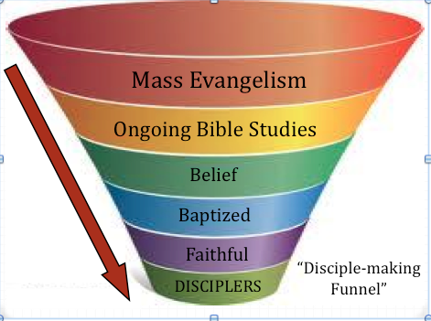

Part 3: What is the biblical method for establishing believers?
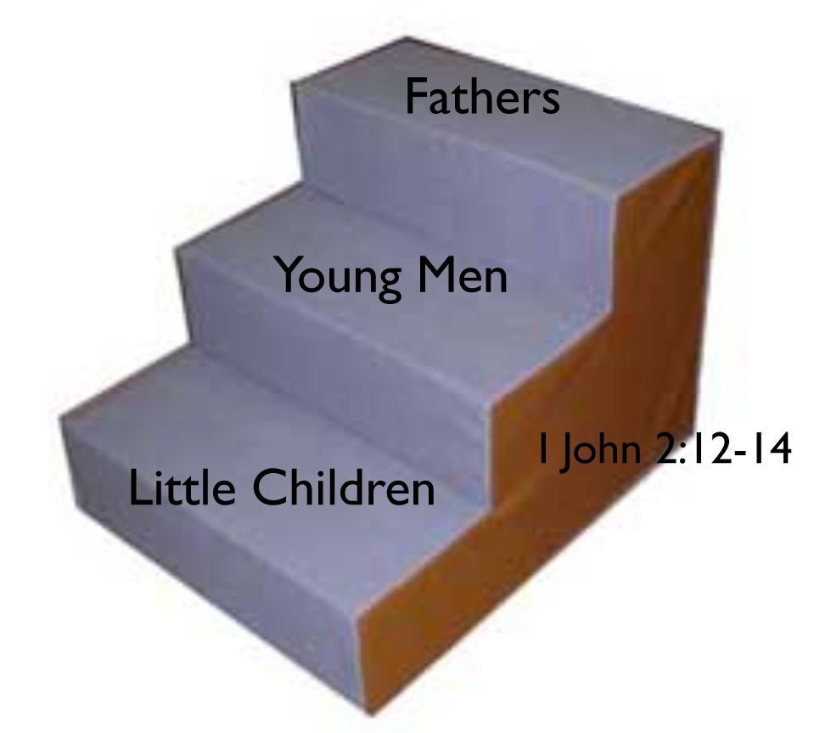

Little Child to Young Man

Average time: 1-2 years
Goals for Spiritual Growth:

1. THE WORD Establish their relationship with Christ 1 John 2:12-13, 1 Peter 1:23
2. THE CHURCH Establish their relationship with the Body of Christ 1 John 2:10
Acts 1:8; 1 Corinthians 12:27
3. HOLINESS Cut ties with their relationship to their old life of sin 1 John 2:15

Conclusion: The key word for all disciples is faithfulness.

#1: Is the new believer spending time with Christ each day in the Word as a joyful habit?
#2: Is the new believer faithful to attending and participating with the church? (participation includes sharing his faith with his friends and family)
#3: Is the new believer rid of all the sinful habits that before plagued him?
Lesson 7 – Exhort To Ministry

Introduction: The third phase of missionary work is exhorting believers to ministry. This phase is the essential level of success.

Four questions to be answered:

1. How do missionaries typically measure success?
Salvations, Baptisms, Church Attendance, or Churches planted?

2. How does the Bible measure success?

Jesus and Paul measured success by one thing: the faithful men they trained.

Jesus with his disciples- Matt. 4:17-25, Mark 1:14-22, Luke 4:16-5:11
Paul in Antioch- Acts 11:19-27, 13:1-2
Paul in the region of Lystra- Acts 14:1-23
Paul with Timothy- Acts 16:1-3
Paul in Corinth- Acts 18:11 & 18
Paul in Galatia and Phrygia- Acts 18:23
Paul in Ephesus- Acts 19:8-10
Paul with Titus, Erastus, Epaphras, Jason, and many others.

Conclusion: Picture the end scene- Jesus with his disciples (Matt. 28:19-20) and Paul with Timothy (2 Tim. 2:2) and Titus (Titus 1). This is success.

3. Wasn’t Paul a bi-vocational preacher? Won’t the expectation of full time ministry stunt multiplication?

Modern missions philosophy: Tentmaking based on Paul’s ministry in Corinth
Acts 18:3, 1 Cor. 4:12, 9:6-12
Should men go into full time or part time ministry? 2 Cor. 12:13
What is the biblical foundation for men going into full time ministry?
1. Description
Jesus himself lived of his preaching
Jesus called his disciples to leave their secular employment
Paul called Timothy and others
Paul himself received support from the churches Philippians, 2 Cor. 8-9
2. Perscription
1 Cor. 9:3-14, 1 Tim. 5:17-18

Conclusion: There will be times and places where bi-vocational preachers are necessary. The biblical goal is to reach full-time Gospel ministry in the local churches.

4. How do we start?
Situation: You have a church started. You’ve evangelized and gathered some people that you are discipling. What do you do?
1. Pray from day one. Mark 1:35-36
2. Look with double vision
3. Preach about the need of the world
4. Retell how God put you into the ministry
5. Start with faithful men
Does he read his Bible alone when encouraged to?
Does he come faithfully to church?
Is he growing in grace?
6. Test faithful men for teachability
7. Take him with you to do ministry
8. Make ministry fun and exciting
9. Make the path to ministry easy to see
10. Give him jobs to do gradually increasing in importance
Lesson 8 – Exercise for Ministry

Introduction: The fourth, and sometimes most difficult yet rewarding step, is to prepare “young men” for ministry.
Examples: Mark 3:14- Jesus with his disciples- 2-3 years
Acts 16:1-4 Paul with Timothy- 8 years
Acts 20:17-38 Paul with the leaders of Ephesus in Miletus- 3 years

In this lesson we’ll talk about how to help young men become fathers.
1. How is a missionary like a coach?
1. A coach must teach people to work together.
2. A coach must motivate his players to want to win.
3. A coach must guide his players in how to win.
5. A coach must let his players play.

2. What are the key areas for development?

Young men-to Fathers
Average time: 3-5 years

Goals for Spiritual Growth:

1. THEOLOGY Learn how to correctly and effectively handle the Word of God.

2. PRACTICE Establish the life-long habit of intentional evangelism and disciple making

3. CHARACTER Develop his inner man (Psalm 15) and relational leadership

Action Steps for the Discipler:
#1: Time teaching.
#2: Time serving.
#3: Time listening.

Completion Questions:

#1: Does the "young man" know how to effectively teach and lead others in Biblical ministry?
#2: Does the "young man" effectively seek out new relationships, share the Gospel, and train "little children" in their three spiritual growth goals? With how many people has he done this?
#3: Does the "young man" harbor unity, peace, and spiritual growth in all of his personal relationships? or are their sparks flying in multiple relationships that he has?

3. Step for developing a training plan for making disciples

Step #1: Identify Goals and Expectations.
Step #2: Write down the desired knowledge base, mindset, and skill set.
Step #3: Determine the courses, texts, teachers, and activities.
Step #4: Determine the scope, sequence, and schedule.
Step #5. Implementation.
Step #6: Make periodic evaluations and adjustments.

Lesson 9 – Export National Pastors

Introduction:
In this lesson we’ll talk about the important task of releasing men to ministry.

I. What models should we look to?
Jesus and his disciples followed these steps:
Come and see- John 1:46
Come and follow me- Mark 8:34
Come and be with me- Mark 3:14
Remain in me- John 15:16
Paul and Timothy as our pattern.

II. What are the basic stages of a pastor’s training?

I do, you watch.
We do.
You do, I watch.
You do.

Timothy’s life followed the following basic stages:
I John 2:12-14
I. Timothy the New Believer Acts 16:1-3
II. Timothy the Apprentice 2 Tim. 3:10
III. Timothy the Spiritual Father 1 Tim. 1:3
III. What are the areas of training that need to be focused on?
Fathers- Need to continually grow in:
1. LEADERSHIP
2. SERVANTHOOD
3. DISCIPLESHIP

IV. How long should it take to train a pastor on the field?
Jesus spent 2-3 years with his disciples.
Paul spent 5-8 years with Timothy between Acts 16-Acts 22

Conclusion:
To raise sons in the faith and export them into ministry is a science, art, and relationship all in one. We can’t go too fast or too slow. It is the best path to a long, multiplying ministry.

Lesson 10 – Exit Indigenous Churches

Introduction:
The moment the missionary exits a church will test the quality of his training. The missionary who never leaves a church, never tests its quality and risks the wasting of many years. In this lesson we’ll look at why it is so important to make churches indigenous and some principles about how to accomplish this goal:

I. What are the key areas of indigenousness?
What is an indigenous church?
1. Self-supporting
2. Self-governing
3. Self-propagating

II. What is the pattern of church planting in the New Testament?
In Paul’s missionary trips, he left indigenous churches in how many cities?
Acts 19:8-10- The Church of Ephesus is a key pattern of church planting and missionary conduct
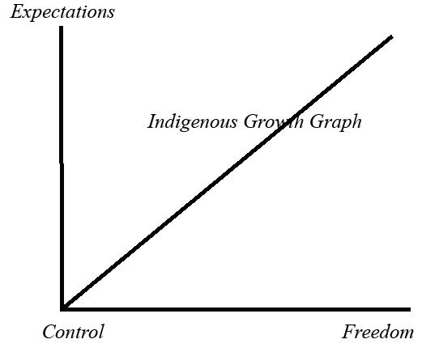
1. Evangelism
2. Discipleship
3. Church planting
4. Missionaries sent
5. Church confirmed Acts 20:16-38

III. What are the basic stages for growing and launching a church?
1. Observation
2. Participation
3. Deputation
4. Full Partnership

IV. What are some obstacles to indigenousness?

Rice Christians Syndrome
Paternalism
Cultural Imperialism
Corner-of-Elm-and-Maple Vision
Fear of failure
Missionary-Doer Philosophy

Lesson 11 – Closed Countries

Introduction:
There are two ways governments have reacted to the mission as described in this course as making disciples of all nations. One way is fairly new: allowing it and protecting it as a right of the people. The second is as old as the first mission: restricting it. This lesson will look at how the church should react to what are known today as closed countries.
1. Where in the world are closed countries?
*Creative Access Country- A country where a missionary must obtain a visa other than missionary such as tourist, business, NGO, student, teacher, etc.
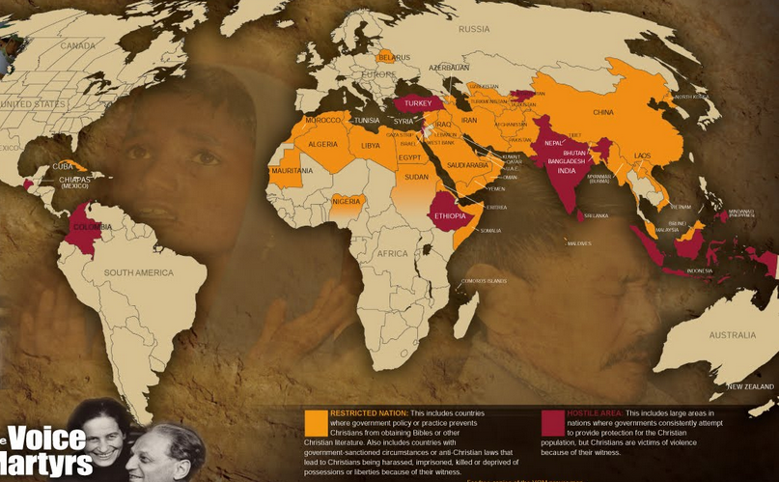
*60% or 4.2 billion people of the world live in countries like this.
Where were closed countries in the Bible?

Jerusalem Acts 8:1
Damascus Acts 9:1-3
Antioch of Pisidia Acts 13:13-51
Iconium Acts 14:1-7
Lystra and Derbe Acts 14:8-20
Philippi Acts 16:16-40
Thessalonica Acts 17:1-9
Ephesus Acts 19
Rome
Smyrna Rev. 2:10
Pergamos Rev. 2:13

2. What are the major trends in missions to closed countries?

Business as Missions and Tent-Making
*5% of missionaries in closed countries are involved in church planting in any way
3. Why are these trends counterproductive?
Jersey obsession:
a) It begins with the wrong goal: longevity Acts 17:1-10
b) It continues with acquiescence to the commands of men Acts 4:18-19
b) It consumes the time of missionaries 2 Tim. 4:2-5
c) It leads to inadequate training for ministry Acts 16-24
d) It gives a false sense of accomplishment 1 Thess 2:19
e) It is the logical consequence of a weak theology of suffering 2 Tim 4:2-5
f) It takes the local church out of the center of strategy Eph. 4:19-20
g) It drives away the gifted evangelist/disciple-maker/church planter from missions to creative access countries
h) It forbids the biblical identity of “pastor” Rom. 1:1
i) It sets the wrong example 2 Tim. 3:10

4. What are biblical roles for closed countries?
Two biblical examples for Creative Access Countries:
1. Paul- A person sent and largely supported to cross cultural, linguistic, and governmental hurdles to evangelize the lost, plant local churches, and disciple believers to maturity.
2. Aquilla and Priscilla- An equally dedicated and sacrificial Christian supported through secular means who works in a support role to the missionary.
5. What did Paul’s mission look like in closed countries?
Setting the record straight on Paul “The Tentmaker”:
a. Paul’s identity- How did Paul identify himself in a new city?
b. Paul’s time- What did Paul dedicate his time to?
c. Paul’s support – How was Paul supported?
d. Paul’s training – How did Paul prepare and how did he prepare others for ministry?
e. Paul’s Field- Did Paul work in a closed country? Did he move around when necessary?
Conclusion: A full-time, church-planting ministry is not only possible in creative access countries but is completely biblical and absolutely necessary.

Lesson 12 – Cultural Adaptation and Language Acquisition

Phil. 2:5-8
1. Definitions of culture
A. The sum total of ways of living built up by a human community and transmitted from one generation to another. (The Gospel and Western Culture)
B. A style of living, a learned behavior. (Jeff Adams)
C. The “rules” of the game of life for any people group.
D. Anything that gives a people group an “us vs. Them” mentality.

II. Diversity of Cultures
A. God-established differences
1. Race
2. Language
3. Age
4. Location
5. Time

B. God-allowed differences
1. Customs
2. Social class
3. Education
4. Religion
5. Vocation

III. Three different views of culture

A. Culture Stands Over Scripture
B. Scripture teaches a culture
C. Culture is transformed by Scripture
In this view there are three things we do with each facet of a culture that we come across:
1. Accept it -We can dress like them. We sit like them. We can love their football teams. We can do our hair like them. We can speak like them. We can eat what they eat. 1 Cor. 9:19-22
2. Reject it
3. Redeem it

IV. Duties of crossing cultures with the Gospel
Incarnational identification: “A model of ministry imitating that of Christ who “became flesh and made his dwelling among us.” John 1:14

A. Humility
Forget your nationality
Leave your political views at home
B. Deference/Respect
C. Flexibility/Adaptability- Learning

Cross-culturalism- “The learned skill of relating to people of other cultures within the contexts of their cultures”

1. Learn to love people
2. Learn to learn
3. Learn the language
4. Learn to utilize culture for the Gospel
5. Learn their sense of humor
6. Learn their hospitality
7. Learn their personal space
8. Learn to look like them
9. Learn how they express masculinity and femininity
10. Learn their sports/teams

Language Acquisition

Introduction: Recognizing the importance of language acquisition in missionary endeavors
- What is the value of learning another language as a foreign missionary?
- How significant is natural ability in the process of language acquisition?
- What does a practical strategy for attaining fluency look like?

- The God-glorifying Value of Language Learning
  - Reasons to learn a language
    - Understanding your surroundings – don’t be a gullible foreigner
    - Broadening your audience – be an equal opportunity preacher
    - Interacting meaningfully with others – cut out the translation buffer
    - Connecting in preaching – showing a God who is Lord of all the earth
    - Modeling a love for Scripture – teach them to fish in their own pond
    - Setting yourself apart – speaking well exerts a certain attraction
  - Ways learning a language glorifies God
    - Crossing a language barrier is an undoing of some specific effects of sin
    - Preaching ability is inextricably tethered to ability in the language
    - Language ability opens the door to incarnation into another culture
    - Discipling relationships are built with intimate conversations
    - The endless failures of language are pride-destroying experiences
    - The perspective of a new language opens new vistas in Bible study
    - This is the first opportunity to justify the extravagant investment of sending

Factoring in Natural Ability
Most people are ‘middle-class’ language learners
Even the most gifted learners have to walk the same path as the rest of us
Work ethic is the most important factor in determining language-learning ability
A true incapacity in language is a good indicator that you ought not go
This does not deny that there are good things to be done by mute missionaries
It is, however, the priority of our sending efforts to be on those who talk

Strategic Guidelines for Study
The process of language learning is similar to the path up a mountain
Do not trust a school – they usually know precious little about how to learn
Set an unreasonable goal – try to be teaching the Bible within a year
Hire a listener – should be brutal, cheap, available, patient, disciplined
Focus on speaking, not writing – whoever talks first wins the language race
Obsess over patterns – wear the grammar rules into the grooves of your brain
Drill pronunciation relentlessly – humbly strengthen your speaking muscles
Memorize sentences – the semantic range of a word makes context vital
Put in an exorbitant number of hours – keep pushing toward 10,000 hours
Mortify feelings of apathy – aim for comfort, expression, function, acceptance
Maintain accountability – take the word of someone who’s climbed a mountain

Section III: The Missionaries

How shall they preach except they be sent?

Who has the responsibility to send the missionary?

Who are the candidates in a local church?

What are the areas the missionary should be trained in?

Lesson 13 – A Church gives, prays, and goes

Introduction: A local church is to a missionary what a nation is to soldier. The soldier is from that nation, supported by that nation, sent by that nation, and returns home again.

What are the activities of a local church in sending a missionary?

- Servant Leaders are developed in the local church Acts 13:1, Acts 16:1-2
- The Holy Spirit calls some faithful men out of the local church Acts 13:2, 16:3
- The local church fasts, prays, and commissions the missionary Acts 13:3
- The missionary reports of all that God has done Acts 14:26-28
- The local church gives financially 2 Cor. 8-9

Conclusion:
Lesson 14 – The Missionary Trainer

Introduction: Missionaries are given the highest chance of success when they are trained well. Just as the ministry of the missionary on the field should be life-on-life, so should his training. Who trains the missionary is the biggest factor.

What kind of man should we look for to train us?
Timothy’s trainer: Paul
- Paul’s method.
A. He practiced “with-ness”. Timothy traveled with Paul (16:4) somewhere around 5,400 miles in total (Carson).
B. He trained in groups. He traveled with Luke, Silas, Timothy and many others.
C. He was anything but emotionally disconnected. I Tim 1:2
II. Paul’s experience
He was probably 20 years his senior or so.
Paul had a deep, personal relationship with Christ.
Paul had been a missionary pastor in Antioch for a number of years and had already completed one tour of Turkey and Cyprus.
He was the most experienced and successful of all preachers at the time (surpassing even Peter in miles traveled, placed preached, and cultures adapted to.)
III. Paul was spiritually a Jewish Christian, legally a Roman, and intellectually a Greek.
Timothy could say that he fully understand each of these areas of Paul’s life that gave him the skill he needed to be the successful missionary he was. II Tim. 3:10-11

Question: Can you say with Timothy that you fully know the doctrine, manner of life, and ministry of a man like Paul not having just watched one from afar?

Lesson 15 – The Missionary Candidate

Introduction: What are the basic characteristics of a missionary? Does a missionary need to be smart? Adventurous? Who should be chosen as a missionary?

In Acts 16:1-3, Paul chooses a young man from a local church to join his missionary team: Timothy. This lesson will look at who Timothy was as a guide for how to choose faithful men from local churches for missionary service today.
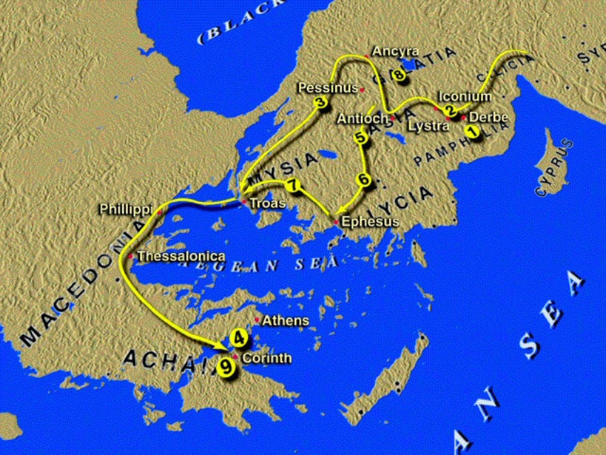
I. Timothy’s hometown
He was from either Derbe or Lystra (most likely Lystra) in a region called Lycaonia 16:1 It was a medium sized town in an economically average area.
This was the same town Paul had preached in, founded a church in, and was stoned outside of Lystra before preaching again in Derbe.
Timothy was possibly present at his stoning (Acts 14:19-20).
His hometown was full of fervent pagan worshippers of Greek gods (they called Paul Mercurius Acts 14:12) but he himself was raised in a Jewish community in a sort of semi-porous bubble.
II. Timothy’s Family
He was raised by a Jewish mother, Eunice, and grandmother, Lois II Tim. 1:5, Acts. 16:1
He was also the son of an unnamed and apparently absent Greek father.
Timothy may have learned from his father’s culture that women were created by Zeus as punishment to man for having obtained fire. (Discovering God, 81)
Marriage between pagan men (outnumbering pagan women) and Christian women (outnumbering Christian men) was common. There was a tax against men 25 years or older (imposed by Augustus in 9 ad) who were not married with children. This led to high levels of divorce or abandonment. (The Rise of Christianity, 116)
III. Timothy’s faith
It is possible that Timothy was won by Paul himself on his first journey to Lystra since Paul calls him his “beloved son” (M. Henry). No doubt, he followed the Jewish faith and then faith in Christ that was first believed by his grandmother and then mother.
He was “well reported of by the bretheren” in his area (Acts 16:2). This leads us to assume he had the big three down:
1. He had learned to not continue in sin (He hated sin)
2. He was faithful to the local congregation (He loved his brothers)
3. He was an diligent student of God’s Word and ardent advocate for the Gospel (He loved Jesus, God’s Word)
IV. Timothy’s choosing.
Paul chose him 16:3 We can assume then that he was:
*Desirous to go.
*He was willing to suffer physically (circumcision).
*He was willing to submit to Paul’s advise.
*He was willing to serve.
*Unattached. No debts. No marriage or marriage hang-ups.

Question: Are you an average guy from an average family from an average town with an un-average desire for God use your life to impact the world still in darkness with the Gospel? Are you willing to pay the price, loose respect, and submit to be trained to do that?

Lesson 16 –The Preparation of the Missionary

Introduction: What should be expected of a missionary before he is sent?

What are the areas specific to cross-cultural missions we need training in?
I. The ability to teach the Apostles Doctrine I Tim 1:3-18
II. Persecution/opposition
1. They faced religious, political, and mob opposition together
In Philippi Acts 16:16-24
In Thesalonica Acts 17:5-9
In Berean Acts 17:13-14
In Ephesus, Corinth, and many other cities
2. He watched as Paul continued in the work and saw prayers answered in the face of this opposition Acts 16:25-36
3. The Holy Spirit encouraged Paul to keep preaching in Corinth Acts 18:9
4. Paul defended the Gospel before the city’s authorities Acts 16:37
5. Timothy himself was imprisoned at some point in Italy as he traveled with Paul Heb. 13:23
II. Developing strategies of evangelization for virgin territories
- 1. Paul determined steps to take
Acts 16:6-10
2. Paul’s team planted new churches in unevangelized cities
They tried out new and old evangelistic strategies
Acts 16:13, 17:1-4, 17:11, 17:17, 18:4, 18:6, 18:8
3. They won and baptized whole families in completely unevangelized contexts
Lydia in Philippi, The Philippian Jailor, Crispus in Corinth among others.
4. They found places of lodging and places for meetings for training for the new church
Acts 16:15, 17:5, 19:10
III. Identifying young leadership in another culture
1. Paul worked with baby churches helping train leaders
Paul taught the Apostles Doctrine to the new church leaders in multiple cities 16:4
2. The churches grew in numbers and multiplied 16:5
3. Traveling preachers were trained and sent out as leaders into all of Asia Acts 19:10
4. Paul ordained men in all the churches around Corinth according to their gifts and abilities. I Cor. 7:17
IV. Creating a financially viable, Biblically defensible economic model for missions
1. Timothy learned to keep ministering with or without even the basic provisions
Phil 4:12
2. He learned to accept gifts from the churches to live of the Gospel
a. Paul taught him the Biblical basis for paying pastors and missionaries for their work. I Cor. 9:14
b. Paul taught him how to communicate well with those who are helping in the work financially. Phil 4:14-15
3. He learned to teach the churches to give I Tim 6:17-18
V. Unmentioned skills in the life of Timothy that may be necessary today
1. Language Acquisition
2. Marriage and family life on the foreign field
Question: Have you had enough experience in these above areas to say that you have mastered them?

